TEACHERS’ PROGRAMME ON PREVENTION OF EARLY SCHOOL LEAVING
MAYO EDUCATION CENTRE
Module 5 – EXTERNAL SUPPORT AND CO-OPERATION

MODULE 5 - EXTERNAL SUPPORT AND CO-OPERATION
April 28th 2009

Welcome and Introductions

Introduction to Module 5 - External Support And Co-Operation
- Aims of the module

Exploration of the project portal
- Exploration of the project portal
- Check into the ‘Meeting Space’
- Respond to posted comments

Module 5 – External Support And Co-Operation

Module 5 – Comments on the module on the forum
- Teacher Experiences – fill out the one page form indicating a personal experience with early school leaving
Evaluation of the workshop

PRESENT were:

Ms Marie Verity
Ms Rosaleen Sullivan
Mr Daniel Forde
Mr Denis O’Boyle
Ms Josephine McDonagh
Ms Sarah Sheridan
Ms Philomena Browne
Ms Aine Ni Chonghamhna

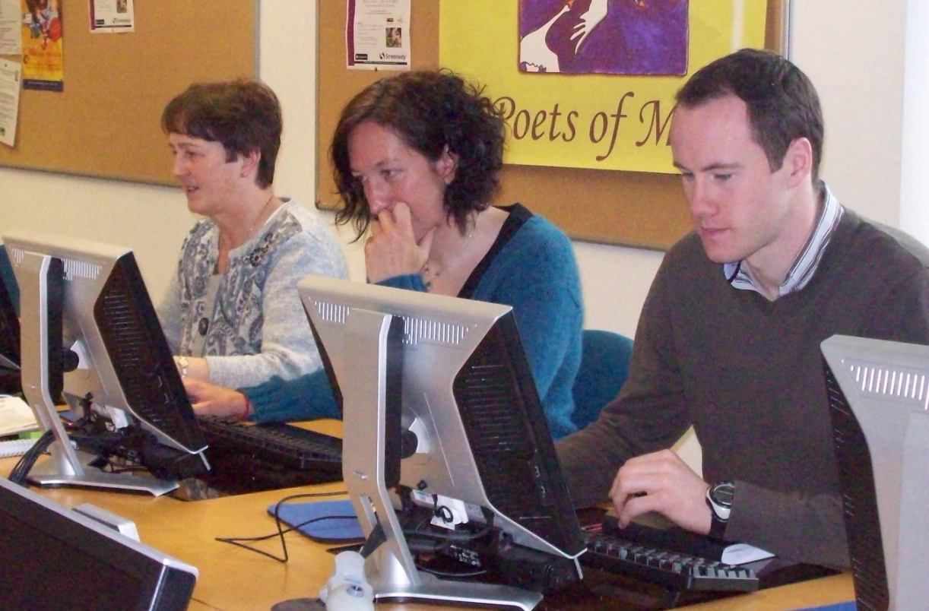

Participants prepared for the workshop by reading the Module 5 document.

On consultation with the Meeting Space – the forum – some were pleased to find comments relating to their input. Others were pleased to relate to comments written by participants in other countries that they could relat to.

STRENGTHS
- The videos presented in Module 5 were considered to be its greatest strength – practical, valuable and positive
- The opportunity to ‘meet’ young school leavers through the videos enabled participants to think differently about the issue and its reality
- Use of young people in the preparation and production of the videos was considered very useful

WEAKNESSES
- More statistics within the module might be useful
- The flag system is usefula nd could be better utilised with more comprehensive information – with examples of high, medium and low risk situations
- Use of ‘hot spots’ for the external flow chart

OPPORTUNITIES
- This module could be used for both teacher and students alike
- The videos could be used in other subjects iwth students who might identify with the scenarios therin

THREATS
- The title of the module did not appear to fit with the information presented in the module

In conclusion Module 5 was accepted as a different approach to training within the Training Package. Its practical application and opportunities offered variety and opportunity

